

|  |
| --- |
| **Unified Sports**  **Skills & Drills Guide Book** |



**Sports Specific Skills & Drills**

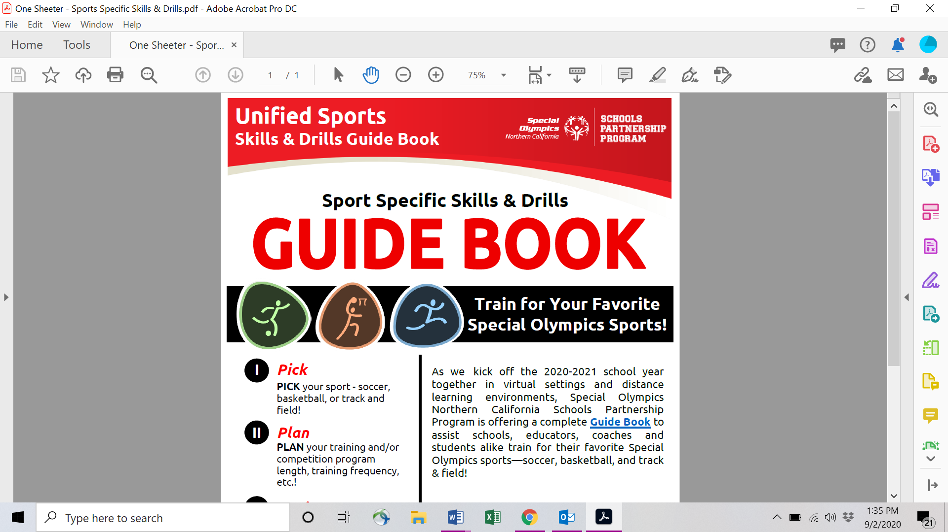

**Guide Book Introduction**

As we all kick off the 2020-2021 school year together in virtual settings and distance learning environments, Special Olympics Northern California (SONC) Schools Partnership Program is offering a complete Guide Book to assist schools, educators, coaches, and students alike train for their favorite Special Olympics sports—soccer, basketball, and track & field!

In this short guide, we offer various resources including fitness and skills videos from professional athletes to help you build and develop a training and competition program that works for your district, school, or classroom. Use our example training programs or create your own!

**How to Use This Guide Book**

1. **PICK** your sport – soccer, basketball, or track and field!
2. **PLAN** your training and/or competition program!
   1. Will your program be training, competition, or both?
   2. What will the length of your program be, and how often will your students train and/or compete?
   3. What’s the best way to implement your Unified program—Zoom, self-report participation/scores, or a mix
3. Use the sport specific resource sections in this Guide Book to **DESIGN** a fun and engaging Unified program!
4. **IMPLEMENT** your program! And be sure to **SHARE** with your Program Coordinator and/or Area Manager!

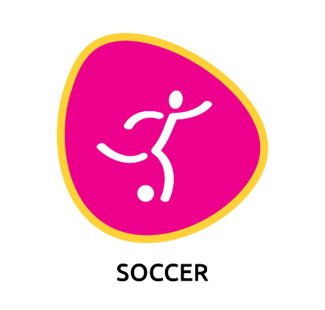

**Example**

**Soccer Program**

This is a 5 week long Unified soccer training and competition program. The first 4 weeks are a training and practice program, and the 5th and final week is a virtual skills competition.

|  |  |  |  |  |  |  |  |
| --- | --- | --- | --- | --- | --- | --- | --- |
|  | Sun | Mon | Tues | Wed | Thurs | Fri | Sat |
| Week 1 |  |  | **Dribbling & Ball Control**  **II & VIII** |  | **Dribbling & Ball Control**  **V & IX** |  |  |
| Week 2 |  |  | **Passing &**  **Receiving III & V** |  | **Passing &**  **Receiving**  **IV & VII** |  |  |
| Week 3 |  |  | **Shooting**  **II** |  | **Shooting**  **V** |  |  |
| Week 4 |  |  | **Throw Ins III & IV** |  | **Goalkeeping II & IV** |  |  |
| Week 5 |  | **Time To Compete!**  **I** | **Time To Compete! III & IV** | **Time To Compete!**  **V** | **Report**  **Scores!** | **Report Scores!** |  |



**Soccer Resources**

Use the soccer resources below to create your very own Special Olympics training/competition program!

**Always Start Every Workout with a Warm Up and Finish with a Cool Down!**

1. Special Olympics – [Warm Up and Cool Down Coaching Guide](https://media.specialolympics.org/resources/sports-essentials/coaching-guides/Coaching-SO-Athletes-Short-Guide-to-Warm-Up-and-Cool-Down.pdf)
2. Special Olympics – [School of Strength Warm Up](https://www.specialolympics.org/school-of-strength/fitness-movies/video-1-welcome-and-warm-up)
3. Special Olympics Colorado – [Soccer Warm Up](https://www.youtube.com/watch?v=5lUzHkirJyw&list=PLHY0PF9u7Dg0P9GIGkwiLiJeJVuNVaEEn&index=3)
4. Special Olympics Colorado – [Soccer Stretching](https://www.youtube.com/watch?v=P8KR2nVkMt0&list=PLHY0PF9u7Dg0P9GIGkwiLiJeJVuNVaEEn&index=4)
5. Special Olympics – [Sample Warm Up/Stretching Activities](https://media.specialolympics.org/soi/files/sports/Football+Home+Training+Guide.pdf) (p. 24-26)

**Improve your Soccer Fitness!**

1. [Footwork](https://sonc.box.com/s/xdgnpzmwgrth7t9bdgf31kubxh6jtc0n) from SONC Student Leader, Ava Ciampi
2. [Football Conditioning Session](https://www.youtube.com/watch?v=blLts_HWGdI) to Improve Your Fitness with the Ball
3. [Fitness Training with a Ball](https://www.youtube.com/watch?v=xhr-NTTvjvw&list=PLsRSijrCyTQeKidO5TNZJEwl0BYHEEqk9&index=4) with San Jose Earthquakes player Tommy Thompson
4. [Ladder Drills](https://www.youtube.com/watch?v=BXkwvaJftPU&list=PLsRSijrCyTQel_Ekr0BVCuGhjGUaMDX84) with San Jose Earthquakes player Tommy Thompson
5. [Agility Ladder Work](https://www.youtube.com/watch?v=tMY5Cj39xN8&feature=youtu.be) with Michael Lewis Cunningham
6. [5 Essential Speed and Agility Drills](https://www.youtube.com/watch?v=3ew2m3m5f0M) with Michael Lewis Cunningham
7. [5-10-5 Drill](https://www.youtube.com/watch?v=VJF5ZEiwU4Y)

**Drills and Activities to Improve Your Soccer Skills!**

**Dribbling and Ball Control**

1. [Soccer Dribbling](https://sonc.box.com/s/3ccwgz53haozqxli4ievb33p9h5yqkie) from SONC Student Leader, Camren Rogers
2. [10 Easy Ball Control Exercises](https://www.youtube.com/watch?v=wIQaz2GMkTs&feature=youtu.be) (Cone Slalom) with Michael Lewis Cunningham
3. [1v1 Dribbling Race](https://www.youtube.com/watch?v=CBs7zesduhk)
4. Become Elite – Full Soccer [Training in a Tiny Box](https://www.youtube.com/watch?v=CgsymJy0RJk)
5. Fast Feet [Beginner Soccer Drills](https://www.youtube.com/watch?v=SoijY4BUCtw)
6. U.S. Soccer Foundation – [Turning the Ball](https://www.youtube.com/watch?v=JZrh6ghuhEM&feature=youtu.be)
7. U.S. Soccer Foundation – [1v1 Attacking/Dribbling Moves](https://www.youtube.com/watch?v=XyYAmVnPgfI&feature=youtu.be)
8. [Dribbling Moves](https://www.youtube.com/watch?v=CRTAEnwmd50&list=PLsRSijrCyTQfdtOl85gJ9u9XBWjyr30W-&index=6) with San Jose Earthquakes Tommy Thompson
9. [9 Easy Skill Moves to Beat Defenders](https://www.youtube.com/watch?v=1sr8zc8nP9Y&t=291s) with Michael Lewis Cunningham
10. [Beginner Juggling](https://www.youtube.com/watch?v=HRFJlPYhFV0&list=PLsRSijrCyTQdXgUazBXHhu1mYqZQUe-sb) with San Jose Earthquakes Tommy Thompson

**Passing and Receiving**

1. [Passing & Trapping](https://sonc.box.com/s/4m83wfao23m78rsv2j7x7dxp8ed38jw4) from SONC Student Leader, Max Duff
2. U.S. Soccer Foundation – [Passing and Receiving](https://www.youtube.com/watch?v=3uoPHkmYgE0&feature=youtu.be)
3. U.S. Soccer Foundation – [Striking the Ball with the Inside of Your Foot](https://www.youtube.com/watch?v=uSM-m4IRq38&feature=youtu.be)
4. How to [Receive](https://www.youtube.com/watch?v=_W6HsUR_0qQ) a Soccer Pass
5. [11-Minute Wall Work](https://www.youtube.com/watch?v=Zn5HWMIxQsQ)
6. [10 Exercises](https://www.youtube.com/watch?v=Jw3bumN_HhU) You Can Do With a Wall
7. Become Elite – 5 Essential [Partner Passing Drills](https://www.youtube.com/watch?v=xvaD2AamMpU&t=117s)
8. [Partner Passing Drill](https://www.youtube.com/watch?v=pRZ-2MOEivM)

**Shooting**

1. [Goal Scoring](https://sonc.box.com/s/c76r9khasbsbtovxh9u81550sbz0irh9) from SONC Student Leader, Max Duff
2. U.S. Soccer Foundation – [Striking the Ball with the Laces](https://www.youtube.com/watch?v=UTjCDT8MguY&feature=youtu.be)
3. Improving Your [Shooting Technique Tutorial](https://www.youtube.com/watch?v=pcPLE_1Eq0k) with Michael Lewis Cunningham
4. Become Elite – [5 Essential Shooting Drills](https://www.youtube.com/watch?v=tcoRi1OxFmo&t=148s)
5. Soccer Coaches – [4 Essential Soccer Shooting Drills](https://www.youtube.com/watch?v=xSe0kmfaXQg) for Youth Players

**Throw Ins**

1. [Throw-Ins](https://sonc.box.com/s/ofv3rv4kx00ae0rq7gfaqtvsek2ayn96) from SONC Student Leader, Chloe Brause
2. How to Master the [Soccer Throw In](https://www.youtube.com/watch?v=cbRRKSB9L1M)
3. Soccer Throw In [Progression Drill](https://www.youtube.com/watch?v=N_4na_Ikm-I) that Works on Technique
4. Throw In [Battle Game](https://www.youtube.com/watch?v=OTeYOBkPErE)
5. [Partner Throw In Drill](https://www.youtube.com/watch?v=gG2wAoNP4WQ)

**Goalkeeping**

1. [Goalkeeping](https://sonc.box.com/s/1qvwhnyleyptgyvqeopm60tsybyai2xn) from SONC Student Leader, Katie Senn
2. [Goalkeeper Fundamentals](https://www.youtube.com/watch?v=qpO_BAPHRg0) for Beginners
3. [Goalkeeper Footwork and Catching Drills](https://www.youtube.com/watch?v=XC2hZh5XpwE)
4. At Home [Youth Goalkeeper Training](https://www.youtube.com/watch?v=sn0KE6pmu4c) for Beginners
5. Fun and Simple [Fundamental Drills for Goalkeepers](https://www.youtube.com/watch?v=JDf3xV92fGM&t=103s)

**Time to Compete!**

1. [Dribbling](https://sonc.box.com/s/nn6ebjttbca9jbta5e0vbajlfj753vz7) Competition
2. [Toe Touches](https://sonc.box.com/s/yxvmzkn8st539ower9ou7ua33cckvv9c) Competition
3. [Unified Passing](https://sonc.box.com/s/7nml3xk35peihbj5lkn7bdjyg3gzfg7g) Competition
4. [Individual Passing](https://sonc.box.com/s/e9lv6wp1n4w619hst3mwc9fkhpckjoqh) Competition
5. [Shooting](https://sonc.box.com/s/azz9iaxm6gty1knv7dlcqu33m4rnjxgu) Competition

**Looking for More Resources? Well Look no Further!**

1. SONC – Soccer [Drill Book](https://drive.google.com/file/d/0B4Jn8RUbJhwUWTZXQ1lfdjR3NDg/view)
2. [Dribbling and Passing Drills](https://www.youtube.com/watch?v=dPeEVP-RL98) with SONC School Area Manager, Brittany Hubler
3. Special Olympics – Together We Play Strong [Training Session Worksheets](https://media.specialolympics.org/resources%2Fcommunity-building%2Fyoung-athletes%2FFootball-Together%23WePlayStrong-Training-sessions-worksheets.pdf?_ga=2.118990345.1828907519.1597704443-228354245.1594080431)
4. Special Olympics – [Developmental Sports Implementation Guide](https://media.specialolympics.org/resources/sports-essentials/developmental-sports/Developmental-Sports-Young-Athletes.pdf?_ga=2.118990345.1828907519.1597704443-228354245.1594080431) Coaching Special Olympics Athletes ages 6-12
5. Special Olympics – [Coaching Resources](https://www.specialolympics.org/get-involved/coach/coaching-resources)
6. Special Olympics – Football (Soccer) [Coaching Guide](http://media.specialolympics.org/soi/files/sports/Football+Coaching+Guide.pdf)
7. Special Olympics – Soccer: A [Handbook](https://media.specialolympics.org/soi/files/sports/Football+Home+Training+Guide.pdf) for Training at Home
8. Special Olympics British Columbia – Soccer [Drill Book](https://www.specialolympics.ca/sites/default/files/SOBC_SoccerSportDrillBook_Aug2012.pdf)
9. Special Olympics Colorado – [Virtual Training Program](https://specialolympicsco.org/virtualtraining/)
10. [Individual Skills Soccer](https://www.youtube.com/watch?v=WWqGOWKM_8o) for SSD Special Olympics Program – Example Drills
11. [US Soccer For Success At Home](https://ussoccerfoundation.org/athome) (Videos available in English and Spanish)
12. MLS Unites – Offers [Workout](https://www.mlssoccer.com/series/mls-unites-workouts) Videos and [Soccer Skills and Drills](https://www.mlssoccer.com/series/mls-unites-soccer-skills-and-drills) Videos
13. San Jose Earthquakes Player, Tommy Thompson’s [YouTube Channel](https://www.youtube.com/channel/UC2zeMHIiHcFoc2eUBvITkyQ/playlists)
14. Michael Lewis Cunningham’s [YouTube Channel](https://www.youtube.com/channel/UC9xRcqG8V6yNi6Hum92EoGg)
15. Ontario Soccer Association – Soccer for Players with a Disability [Resource Manual](http://osadev.cansportlive2.com/Portals/438/clubdevelopment/Soccer%20for%20Players%20with%20a%20Disability%20Manual.pdf)
16. Tennessee Soccer Club [Virtual Training Center](https://www.tennesseesoccerclub.org/supplemental-programs/tsc-virtual-training-center)
17. Cap City Athletic – [Home Work Out Videos](https://www.capcityathletic.com/Default.aspx?tabid=1004075)
18. United Soccer Coaches – At Home [Strength Program](https://unitedsoccercoaches.org/sr-24-4-1/)

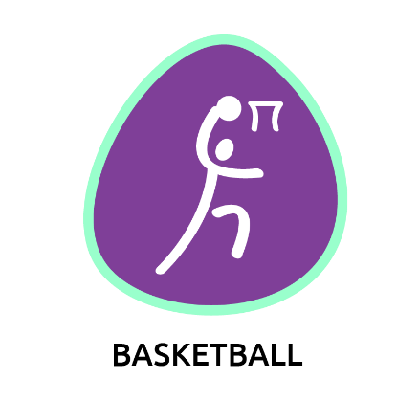

**Example**

**Basketball Program**

This is a 5 week long Unified basketball training and competition program. The first 4 weeks are a training and practice program, and the 5th and final week is a virtual skills competition.

|  |  |  |  |  |  |  |  |
| --- | --- | --- | --- | --- | --- | --- | --- |
|  | Sun | Mon | Tues | Wed | Thurs | Fri | Sat |
| Week 1 |  |  | **Dribbling**  **I & III** |  | **Dribbling**  **V & VII** |  |  |
| Week 2 |  |  | **Passing**  **I & II** |  | **Passing**  **V & VI** |  |  |
| Week 3 |  |  | **Shooting, Layups, & Free Throws**  **I & III** |  | **Shooting, Layups, & Free Throws**  **II & VI** |  |  |
| Week 4 |  |  | **Rebounding**  **I** |  | **Rebounding**  **IV** |  |  |
| Week 5 |  | **Time To Compete!**  **II & III** | **Time To Compete! IV & V** | **Time To Compete!**  **VII & VIII** | **Report**  **Scores!** | **Report Scores!** |  |



**Basketball Resources**

Use the basketball resources below to create your very own Special Olympics training/competition program!

**Always Start Every Workout with a Warm Up and Finish with a Cool Down!**

1. Special Olympics – [Warm Up and Cool Down Coaching Guide](https://media.specialolympics.org/resources/sports-essentials/coaching-guides/Coaching-SO-Athletes-Short-Guide-to-Warm-Up-and-Cool-Down.pdf)
2. Special Olympics – [School of Strength Warm Up](https://www.specialolympics.org/school-of-strength/fitness-movies/video-1-welcome-and-warm-up)
3. Special Olympics Colorado – [Basketball Warm Up](https://www.youtube.com/watch?v=H_Pl2-VaURQ)
4. Special Olympics Colorado – [Basketball Stretching](https://www.youtube.com/watch?v=z-jA9iOThMU)

**Improve your Basketball Fitness!**

1. Special Olympics Pennsylvania – [Virtual Basketball Camp](https://www.youtube.com/watch?v=KS2iPlFcWOw)
2. Jr. NBA – [20 Minute at Home Workout](https://www.youtube.com/watch?v=dX6lZ0hKT8o) with Bruce Bowen
3. Jr. NBA – [No Ladder, No Problem Drill](https://www.youtube.com/watch?v=Y0ZGtSX4xJA) with Daniel Shapiro
4. [The Ultimate Basketball At-Home Workout Guide](https://www.youtube.com/watch?v=GNv-hkfAFtg)
5. [Top 5 Strength Exercises](https://www.youtube.com/watch?v=BW_L2Njcwgc) for Basketball Players
6. NCHPAD – [Agility Ladder Exercises](https://www.youtube.com/watch?v=gxFtEyTkKvI) Benefit Children with Autism
7. [5-10-5 Drill](https://www.youtube.com/watch?v=VJF5ZEiwU4Y)

**Drills and Activities to Improve Your Basketball Skills!**

**Dribbling**

1. Jr. NBA – [Fundamentals of Dribbling](https://www.youtube.com/watch?v=BnvGa0I8bMc) with Isiah Thomas
2. Special Olympics Michigan – [Speed Dribbling Challenge](https://www.youtube.com/watch?v=SKFKY-HB58o)
3. Special Olympics Wisconsin – [12 Meter Dribble](https://www.youtube.com/watch?v=CayRNS-97o4&feature=youtu.be)
4. Basketball [Dribbling Drills for Beginners](https://www.youtube.com/watch?v=coCdV86FPeQ) with Joseph Martinez
5. [5 Dribbling Drills](https://www.youtube.com/watch?v=a6rPVGkGpds) Every Player Should Do
6. [6 Best Dribbling Drills for Kids](https://www.youtube.com/watch?v=MRrNi7uHmaY)
7. Jr. NBA – [Cone Dribbling Drill](https://www.youtube.com/watch?v=1Sp_dQorGvA) with Coach John Beckett

**Passing**

1. [Two-Handed Chest and Bounce Passing Basics](https://www.youtube.com/watch?v=sKd6aAN8CeY)
2. Special Olympics Wisconsin – [Target Pass](https://www.youtube.com/watch?v=8wvqZ_dyXhQ&feature=youtu.be) with Mark Wolfgram
3. Special Olympics Wisconsin – [Catch and Pass](https://www.youtube.com/watch?v=moGusPkGVa8&feature=youtu.be) with Mark Wolfgram
4. Jr. NBA – [Shadow Passing Drill](https://www.youtube.com/watch?v=T8ZQbk4xBBU) with Evan Unrau
5. Jr. NBA – [Stationary Partner Passing Drill](https://www.youtube.com/watch?v=HL6KBD31-zQ) with Rita Williams
6. Jr. NBA – [Jump Stop, Pivot, and Pass Drill](https://www.youtube.com/watch?v=jgqdv9ySjYM) with Coach Jeremiah Boswell

**Shooting, Layups, and Free Throws**

1. Jr. NBA – [Fundamentals of Shooting](https://www.youtube.com/watch?v=t7ciq_x4138) with Allan Houston
2. [Basketball Lay Up Progression Drills for Beginners](https://www.youtube.com/watch?v=Tm7N2HU4noQ)
3. Jr. NBA – [Fundamentals of the Free Throw](https://www.youtube.com/watch?v=lnuZNZPDvaY) with Coach Megan Griffith
4. [Individual Shooting Drills](https://www.youtube.com/watch?v=BgEzaJugxP4)
5. Jr. NBA – [Jump Shot Shooting Drill](https://www.youtube.com/watch?v=AueLd1-H1V8) with Coach Jon Babul
6. Jr. NBA – [Layup Skip Drill](https://www.youtube.com/watch?v=9z6NtAuiB4U) with Coach Jeremiah Boswell
7. [Free Throw Shooting Drill](https://www.youtube.com/watch?v=TOKxsGoOVx8)

**Rebounding**

1. Jr. NBA – 7 Videos of [Rebounding Drills](https://www.youtube.com/playlist?list=PLmPIogZWH3R7gz2RyNlqYensTYcBRss5X)
2. [Defensive Rebounding](https://www.youtube.com/watch?v=yt3PAdzMdtw)
3. [Offensive Basketball Rebounding](https://www.youtube.com/watch?v=8DyK4ZUdlt0&t=201s)
4. Jr. NBA – [Rebound and Score Drill](https://www.youtube.com/watch?v=f2Pr1pGTLo4) with Coach David Vanterpool

**Time to Compete!**

1. [Single-Hand Dribble](https://sonc.box.com/s/tw7tlj072bc9ufwim0k6567bx9stgrvu) Competition
2. [Alternating Hand Dribble](https://sonc.box.com/s/zivrusvmu65yiudf8ktdivkoaae8kt0s) Competition
3. [Dribble Race (10 Meters)](https://sonc.box.com/s/azfwb4epopvugxt0f3lwe1c5535k7qff) Competition
4. [Chest Pass](https://sonc.box.com/s/trysbmptyttjar2x6ic6n5uhmjutbu7b) Competition
5. [Bounce Pass](https://sonc.box.com/s/9jbg1klf5vd8swgzrvgsmr1mexfwqiwj) Competition
6. [Individual Layups](https://sonc.box.com/s/kol37bip3r69ifk1j90ahjlayavyufir) Competition
7. [Unified Layups](https://sonc.box.com/s/g6znqmdcchkzfw1esbkfo8k9zloemufe) Competition
8. [Free Throws](https://sonc.box.com/s/pmu1ttz4e88ldmu888xfi4no4wlllkcm) Competition

**Looking for More Resources? Well Look no Further!**

1. SONC – Basketball [Drill Book](https://drive.google.com/file/d/0B4Jn8RUbJhwUSUhUVWdQLWVYeXM/view)
2. SONC – [Basketball Rules and Guidelines](https://www.sonc.org/sites/default/files/2020_basketball_rules_-_final.pdf) (Example skills competitions on p. 14-18)
3. Special Olympics – [Basketball Coaching Guide](http://media.specialolympics.org/soi/files/sports/Basketball+Coaching+Guide.pdf)
4. FIBA Mini Basketball [Coaching Guide and Resources](https://media.specialolympics.org/resources/community-building/young-athletes/Young-Athletes-Mini-Basketball-English.pdf?_ga=2.118990345.1828907519.1597704443-228354245.1594080431)
5. Special Olympics – [Developmental Sports Implementation Guide](https://media.specialolympics.org/resources/sports-essentials/developmental-sports/Developmental-Sports-Young-Athletes.pdf?_ga=2.118990345.1828907519.1597704443-228354245.1594080431) Coaching Special Olympics Athletes ages 6-12
6. Special Olympics Colorado – [Youth Basketball Drills](http://www.specialolympicsco.org/wp-content/uploads/2018/12/Basketball-Youth-Drills.pdf)
7. Special Olympics Missouri – [Coach Trainings](https://www.youtube.com/watch?v=IjRIentN2Ts)
8. NCHPAD – [Basketball Activities for Children with Autism](https://www.youtube.com/watch?v=MfcqfQ82z-w)
9. Jr. NBA – [YouTube Channel](https://www.youtube.com/channel/UCuA7P9O4_YEJHa6epPnWAbg)

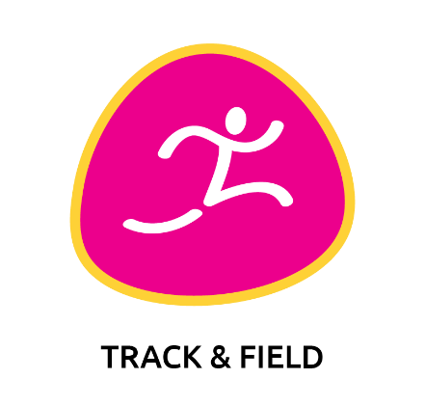

**Example**

**Track and Field Program**

This is a 5 week long Unified track and field training and competition program. The first 4 weeks are a training and practice program, and the 5th and final week is a virtual skills competition.

|  |  |  |  |  |  |  |  |
| --- | --- | --- | --- | --- | --- | --- | --- |
|  | Sun | Mon | Tues | Wed | Thurs | Fri | Sat |
| Week 1 |  |  | **Running**  **III & IV** |  | **Running**  **V** |  |  |
| Week 2 |  |  | **Long Jump**  **I** |  | **Long Jump**  **IV & V** |  |  |
| Week 3 |  |  | **Shot Put and Ball Throw**  **VII & VIII** |  | **Shot Put and Ball Throw**  **I & IV** |  |  |
| Week 4 |  |  | **Javelin**  **I** |  | **Improve your Track and Field Fitness!**  **I** |  |  |
| Week 5 |  | **Time To Compete!**  **I** | **Time To Compete! II** | **Time To Compete!**  **III** | **Report**  **Scores!** | **Report Scores!** |  |



**Track and Field Resources**

Use the track and field resources below to create your very own Special Olympics training/competition program!

**Always Start Every Workout with a Warm Up and Finish with a Cool Down!**

1. Special Olympics – [Warm Up and Cool Down Coaching Guide](https://media.specialolympics.org/resources/sports-essentials/coaching-guides/Coaching-SO-Athletes-Short-Guide-to-Warm-Up-and-Cool-Down.pdf)
2. Special Olympics – [School of Strength Warm Up](https://www.specialolympics.org/school-of-strength/fitness-movies/video-1-welcome-and-warm-up)
3. Special Olympics Colorado – [Track & Field Warm Up](https://www.youtube.com/watch?v=1cDQbU9nMO8&list=PLHY0PF9u7Dg0P9GIGkwiLiJeJVuNVaEEn&index=2&t=27s)
4. Special Olympics Colorado – [Track & Field Stretches](https://www.youtube.com/watch?v=RIdhnSA--kU&list=PLHY0PF9u7Dg0P9GIGkwiLiJeJVuNVaEEn&index=2)
5. Special Olympics Arizona – [Track & Field Warm Up](https://www.youtube.com/watch?v=_v7x5L7D79Q)
6. Special Olympics – [Sample Warm Up/Stretching Activities](https://sonc.app.box.com/file/698469687659) (p. 24-26)

**Improve your Track and Field Fitness!**

1. My Sports Mentor – [10 Plyometric Drills for Athletes](https://www.youtube.com/watch?v=5SQviRdHHRI)
2. Track and Field [Sprint Drills](https://www.youtube.com/watch?v=8LuZWIkOqrQ)
3. [4 Ways to Improve Acceleration](https://www.youtube.com/watch?v=39Tge5HAbc8)
4. Key [Plyometric Drills](https://www.youtube.com/watch?v=QB39BvOt7gQ) for Long Jumpers!
5. [Strength Training Routine](https://www.youtube.com/watch?v=KcPQfxw9EW0) for Distance Runners
6. Championship Productions – [Build Your Shot Putters’ Core Muscles!](https://www.youtube.com/watch?v=ikwrXDY3Qy8&feature=youtu.be)
7. [5-10-5 Drill](https://www.youtube.com/watch?v=VJF5ZEiwU4Y)

**Drills and Activities to Improve Your Track and Field Skills!**

**Running**

1. [How to Racewalk](https://www.youtube.com/watch?v=jOzvn6NpeMU&feature=youtu.be)
2. [How to Sprint Drills](https://www.youtube.com/watch?v=FQmD1Jvpce4&t=27s) with Shaun Spencer
3. Complete Track – [Top 3 Sprint Drills](https://www.youtube.com/watch?v=uqGytI20ggc&feature=youtu.be)
4. [3 Speed Training Drills](https://www.youtube.com/watch?v=voQsUnI7V14)
5. Pro: Direct Running – [Speed Drills for Middle Distance Runners](https://www.youtube.com/watch?v=gWfzevJs_b4) with Jamie Webb
6. Championship Productions – [Master the Relay Handoff](https://www.youtube.com/watch?v=uYgipxoSWAI&feature=youtu.be)

**Long Jump**

1. Standing Long Jump [Fundamentals](https://www.youtube.com/watch?v=dVgtvAXeBQw)
2. Running Long Jump [Approach 1](https://www.youtube.com/watch?v=1XW_EHq4nh0&feature=youtu.be)
3. Running Long Jump [Approach 2](https://www.youtube.com/watch?v=PBgTXdCUmZ4&feature=youtu.be)
4. [Take Off Drills](https://www.youtube.com/watch?v=lxldLamtuLQ&feature=youtu.be)
5. [Long Jump Workout](https://www.youtube.com/watch?v=yVhYUsl8K1M)
6. [Typical Long Jump Workout](https://www.youtube.com/watch?v=yVhYUsl8K1M&t=5s)

**Shot Put and Ball Throw**

1. Sports and Outdoors – [Basic Guide To Shot Putting](https://www.youtube.com/watch?v=_eKlMTqg2JU)
2. [How to throw Shot Put](https://www.youtube.com/watch?v=TJzP-x5oezs) with professional thrower, John Bowman
3. [Shot Put Balance Posture & Strength](https://www.youtube.com/watch?v=peuPYeriwCc) with professional thrower, John Bowman
4. Madison Throws Club – [Shot Put Drills 1](https://www.youtube.com/watch?v=Ajn3Dwk8bCQ&feature=youtu.be)
5. Madison Throws Club – [Shot Put Drills 2](https://www.youtube.com/watch?v=Ajn3Dwk8bCQ&feature=youtu.be)
6. Special Olympics – [Softball Throw](https://www.youtube.com/watch?v=SsjQr1U0Bps)
7. Special Olympics – [Tennis Ball Throw](https://www.youtube.com/watch?v=z-E818UntEg)
8. [Tennis Ball Throw Challenge](https://www.youtube.com/watch?v=N7aL6ttU-2o)

**Javelin**

1. [Turbo Javelin Training](https://www.youtube.com/playlist?list=PL7A6CE4881460B9E7) – 9 Videos of Different Training Drills
2. Special Olympics Pennsylvania – [Mini Javelin Training Video](https://www.youtube.com/watch?v=opqmwVb0zDk)
3. [Teaching the Turbo Jav](https://www.youtube.com/watch?v=ZHOITEJKMZw)

**Time to Compete!**

1. [Walk, Run, or Roll (10, 25, 50, & 100 Meters)](https://sonc.box.com/s/3k6ido48w5yt809v53yconpwyv7fzky6) Competition
2. [Standing Long Jump](https://sonc.box.com/s/1t7zvmwtlrr6l9s16386sycyfdxxvb2a) Competition
3. [Ball Throw](https://sonc.box.com/s/o8p31oilewywkznu5gm9l76fda7j0g19) Competition

**Looking for More Resources? Well Look no Further!**

1. SONC – Track & Field [Drill Book](https://drive.google.com/file/d/0B4Jn8RUbJhwUT19Ya2lUVGZhTVE/view)
2. SONC – [Track & Field Resources](https://www.sonc.org/track-field-resources)
3. San Mateo County Office of Education – [Virtual Track & Field](https://sites.google.com/smcoe.org/smcoes-virtual-special-olympic/home)
4. Monterey – Virtual Track & Field [Opening](https://www.youtube.com/watch?v=erPAMWkyLwg&t=5s&app=desktop) and [Closing](https://www.youtube.com/watch?v=vw3_XYZdWJA) Ceremonies
5. Special Olympics – [Athletics Coaching Guide](http://media.specialolympics.org/soi/files/sports/Athletics+Coaching+Guide.pdf)
6. Special Olympics Colorado – [Virtual Training Program](https://specialolympicsco.org/virtualtraining/)
7. Special Olympics Colorado – [Track & Field Training Drills](https://www.specialolympicsco.org/wp-content/uploads/2018/12/Track-and-Field-Training-Drills.pdf)
8. Special Olympics Maine – [Athletics Training at Home Guide](https://www.sonc.org/sites/default/files/athletics-home-trainig-guide_forms_pp20-33.pdf)
9. Special Olympics – [Developmental Sports Implementation Guide](https://media.specialolympics.org/resources/sports-essentials/developmental-sports/Developmental-Sports-Young-Athletes.pdf?_ga=2.118990345.1828907519.1597704443-228354245.1594080431) Coaching Special Olympics Athletes ages 6-12

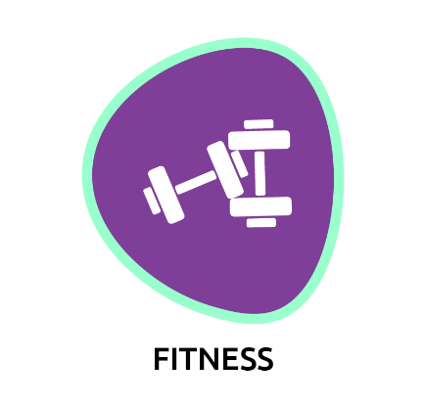

**General Sport Related Fitness Resources**

**Warm Up and Cool Down**

1. Special Olympics – [Warm Up and Cool Down Coaching Guide](https://media.specialolympics.org/resources/sports-essentials/coaching-guides/Coaching-SO-Athletes-Short-Guide-to-Warm-Up-and-Cool-Down.pdf)
2. Special Olympics – [School of Strength Warm Up](https://www.specialolympics.org/school-of-strength/fitness-movies/video-1-welcome-and-warm-up)
3. Special Olympics – [Sample Warm Up/Stretching Activities](https://sonc.app.box.com/file/698469687659) (p. 24-26)

**Strength and Conditioning**

1. [Fitness Exercises](https://sonc.box.com/s/c2jxu85j5nz471zx3wa7il4h885pp8xw) from SONC Student Leaders
2. Special Olympics Pennsylvania – [Commit to Fit Videos](https://www.youtube.com/watch?v=elZX0sAY_sg&list=PLf2qHgFptlX4Hz-BxcE-co8UsY1TeFEpw&index=2&t=0s)
3. Special Olympics Colorado – [General Sports Drills](https://www.youtube.com/watch?v=r1fH_nv1sfk&feature=youtu.be)
4. Special Olympics – [School of Strength Ignite Your Endurance](https://www.specialolympics.org/school-of-strength/fitness-movies/video-2-ignite-your-endurance)
5. Special Olympics – [School of Strength Getting Schooled on Strength](https://www.specialolympics.org/school-of-strength/fitness-movies/video-3-getting-schooled-on-strength)

**Agilities and Speed**

1. [Ladder Drills](https://www.youtube.com/watch?v=BXkwvaJftPU&list=PLsRSijrCyTQel_Ekr0BVCuGhjGUaMDX84) with San Jose Earthquakes player Tommy Thompson
2. [Agility Ladder Work](https://www.youtube.com/watch?v=tMY5Cj39xN8&feature=youtu.be) with Michael Lewis Cunningham
3. [5 Essential Speed and Agility Drills](https://www.youtube.com/watch?v=3ew2m3m5f0M) with Michael Lewis Cunningham
4. [5-10-5 Drill](https://www.youtube.com/watch?v=VJF5ZEiwU4Y)

**Balance and Flexibility**

1. Special Olympics Colorado – [Balance Training](https://www.youtube.com/watch?v=CPrKHPFt_-g&feature=youtu.be)
2. Special Olympics Colorado – [Flexibility Training](https://www.youtube.com/watch?v=_7l7TRoxy_g&feature=youtu.be)
3. Special Olympics – [School of Strength Boost Your Balance](https://www.youtube.com/watch?v=iBtBgkG-aDQ)
4. [Total Body Stretching](https://www.youtube.com/watch?v=y9fNh7cYo64&feature=youtu.be)