__(month)__ ##, 20__

Dear Parent/Guardian,

We are pleased to announce that __(school entity name)__ has partnered with Special Olympics Northern California to offer the Schools Partnership Program at your child’s school!

The Special Olympics Schools Partnership Program is a unique education program in K-12 schools. It unifies students with and without disabilities through **Sports** and **Whole-School Involvement** activities that provide them with the knowledge, experience, and skills necessary to create and sustain school communities that promote inclusion, acceptance, and respect for all students. Currently, over 8,100 special education students and 23,000 general education students participate in the program at over 350 schools in Northern California.

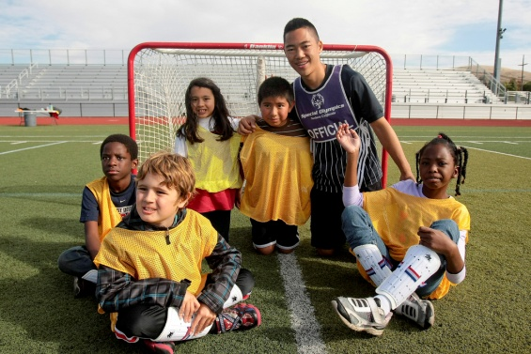

**Sports:** Students engage in eight weeks of training in a specific sport, followed by a culminating competition attended by students from schools throughout the district.

**Whole-School Involvement**: Students engage in activities that use the Special Olympics sports and education program to promote a campus culture of acceptance and social inclusion where all young people are agents of change.

As a part of the Schools Partnership Program, your child has the opportunity to participate in a __(sport)__ competition that will take place on **__(day)__, __(month)__ ##, 20__ from 9:00am to 12:00pm at __(location)__.** Family members and friends are encouraged to attend!

Please sign the enclosed permission slip and return it to your child’s teacher no later than __(day)__, __(month)__ ##.

Sincerely,

**Program Coordinator Name Special Olympics Staff Name**

Program Coordinator, Schools Partnership Program Special Olympics Staff Title

Title Special Olympics Northern California

Phone Phone

Email Email