Dear Teachers and Administrators,

We are excited to announce that __(School Name)__, __(School Name)__, and __(School Name)__ will participate in the Special Olympics Schools Partnership Program during the 20XX-20XX school year!

The Schools Partnership Program is a unique education program in K-12 schools. It unifies students with and without disabilities through **Unified Sports** and **Whole-School Involvement** activities that provide them with the knowledge, experience, and skills necessary to create and sustain school communities that promote inclusion, acceptance, and respect for all students. Currently, over 8,100 special education students and 23,000 general education students participate in the program at over 350 schools in Northern California.

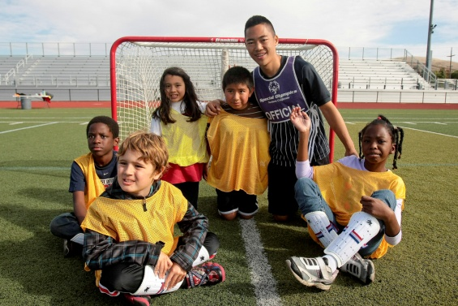

**Unified Sports:** Combines students with and without disabilities on sports teams for training and competition.

**Whole-School Involvement**: Youth-centered, school-focused that uses the Special Olympics sports and education program to activate all students, engage educators, involve the entire school, and promote a campus culture of acceptance and social inclusion where all young people are agents of change.

To learn more about the Special Olympics Schools Partnership Program and how you can get involved, please attend the kick-off meeting.

**Schools Partnership Program Kick-Off Meeting**

**__(month)__ XX, 20XX**

**XXpm**

**__(location)__**

If you cannot attend the kick-off meeting, but would like more information about how to get involved, please contact __(Program Coordinator name)__.

Sincerely,

**Program Coordinator Name Special Olympics Staff Name**

Program Coordinator, Schools Partnership Program Special Olympics Staff Title

Title Special Olympics Northern California

Phone Phone

Email Email