**Young Athletes Program Activities Resources**

Every day before beginning, we encourage you to do the warm-up before proceeding to the activities.

If the athlete is at the right age to do these on their own then that is amazing however, if the athlete is not then it would be best for parents or older siblings to assist with these activities.

**Warm-up:**

* These warm-ups are great to do before engaging in the activities!

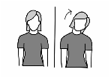**Neck exercise: Do exercise 3 times for 15 seconds each.**

1. Stand up straight.
2. Look straight ahead while bending neck from side to side (in a slow motion).
3. Move ear toward shoulder without moving shoulder.

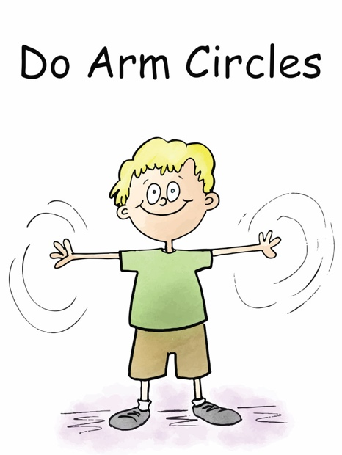

**Shoulder exercise: Do stretch 3 times for 15 seconds each.**

**Arm circles**

1. Stand up straight
2. Look straight ahead
3. Bring arms up and out to the side
4. Do arm circles forward with arms
5. Then, do arm circles backwards with arms

**Lower body exercise: Do these 2 times and hold for 15 seconds**

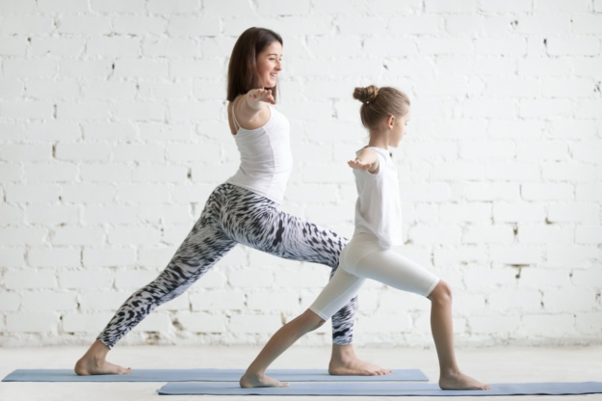**Knee Lunge**

1. Stand straight with arms out to the side.
2. Take one step forward. Make sure the knee is in line with the ankle
3. The knee should not go over the toes.
4. This position should be held for a few seconds.
5. Repeat the same by changing the legs.

**Leg stretch: Do this twice and hold for 15 seconds**

**Butterfly stretch**

1. Sit down with folded legs.
2. Bring the feet together such that the soles touch one another.
3. Let the knees stretch apart while the soles continue to stay in contact. The back should remain straight and slightly lifted.
4. Slowly straighten your legs out in front of you to relax.

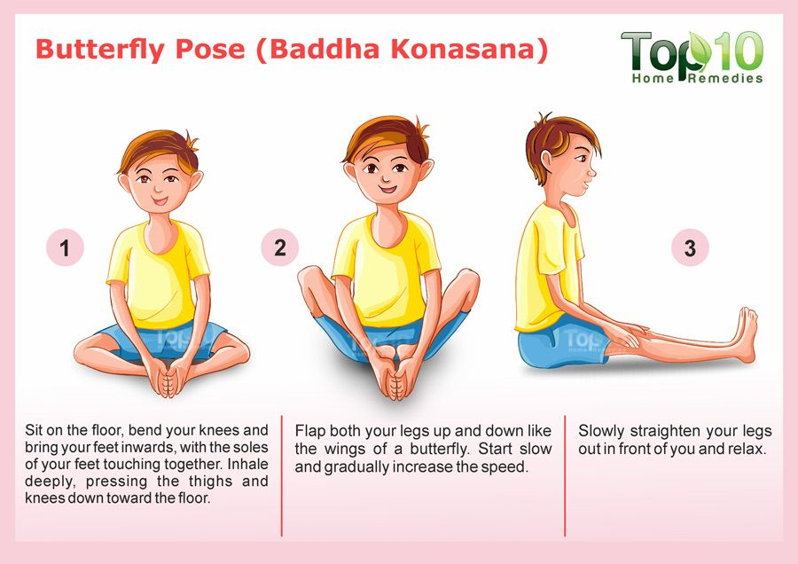

**Activities:**

* These activities resources are great for athletes to continue to work on their skills. If the athlete is at the right age to do these on their own then that is amazing however, if the athlete is not then it would be best for parents or older siblings to assist with these activities.

**Week 1:**

* This week you are able to focus on creating the tightrope and work on balance
* Then progress it with adding obstacles or items in both hands (If athlete feels comfortable)
* **There are images for reference**

**Tightrope walking (Works on walking and balance)**

* **Items needed:** A long piece of string, line of tape, or create a straight line (imagine a line).
  1. Participant will create a straight enough line on the floor with item.
  2. Once participant is ready, walk on the straight line as if it were a balance beam.
  3. Placing the heel of one foot in front of the toes of the other, step by step.
  4. Having arms out to the side to allow for better balance.
* **Progression (a challenge or level up):** Add an item on the line as an obstacle for jumping over (Works on jumping)

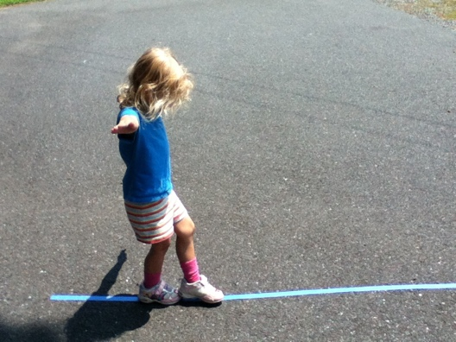

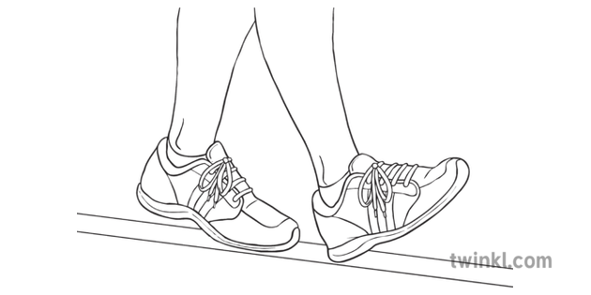

**Week 2:**

* For this week, you are able to work on walking backwards
* If the athlete is feeling comfortable then adding obstacles or items in hands for progression.

**Tightrope walking (Works on walking and balance)**

* **Items needed:** A long piece of string, line of tape, or create a straight line (imagine a line).
  1. Participant will create a straight enough line on the floor with item.
  2. Once participant is ready, walk on the straight line as if it were a balance beam.
  3. Placing the heel of one foot in front of the toes of the other, step by step.
  4. Having arms out to the side to allow for better balance.

**Progression (a challenge or level up):** Add an item on the line as an obstacle for jumping over (Works on jumping)

* 1. **Challenge by choice**: Walk backwards

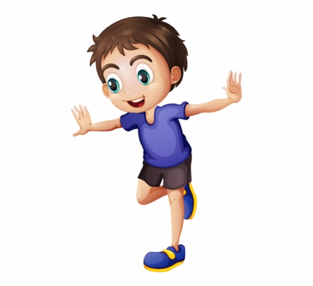**Week 3:**

* For this week, the athlete is able to work on balancing on one foot.
* If the athlete is comfortable then add in the progressions
* Take your time and go at a pace the athlete is most comfortable with.
* **There are images for reference**

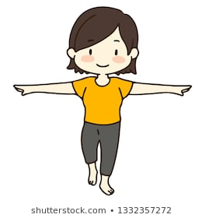**Standing on one foot**

1. Child will stand on right foot
2. Hold – 15 secs
3. Then, child will switch and stand on left foot
4. Hold – 15 secs

* **Progression (a challenge or level up):** Increase hold time
* **Progression (a challenge or level up):** Have a pillow in each hand
* **Progression (a challenge or level up):** Have books on each hand
  + **Challenge by choice:** Jumping on one foot (Works on jumping)

**Week 4:**

For this week, the scarf is a great activity to do with the athlete!

* If the athlete is comfortable then add in the progressions
* Take your time and go at a pace the athlete is most comfortable with.
* **There is a video and image for reference**

**Scarf Games**

* **Items needed:** Scarf, piece of paper, or tissue paper.
  1. Encourage children to follow the movement of the scarf with their head and eyes.
  2. Drop the scarf (If there is a parent or sibling around)
  3. Throw the scarf up (if participant is doing this alone)
  4. Encourage participant to “catch” the scarf with their hands, head, legs, and other body parts
* **Progression (a challenge or level up):** Increase scarves to throw up and try to catch as much as possible.
  + **Challenge by choice:** Let the scarves fall as low as possible then catch it
* 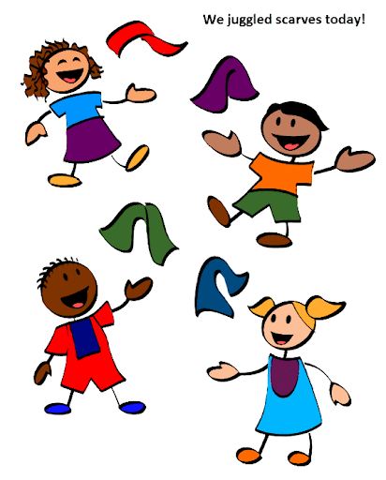**YouTube link for a visual:** <https://www.youtube.com/watch?v=PRYXfR9-ixs>

**Week 5:**

* For this week, the athletes will work on running and stopping
  + Enhancing control

**Running:**

1. Participant will begin with running in place.
2. Next, participant will create a straight enough line on the floor with item (does not have to be long)
3. Participant will run from one end of the straight line
   1. Participant will make sure to stop at the end of the straight line
4. Turn around and run to other end of the straight line
5. Repeat
   1. Participants will do these 10 times

**Progression: Add cones, books, or other items for the athletes to maneuver around.**

**Week 6:**

* For this week, once athletes have more control with running and maneuver.
* You are able to progress and add side way runs (lateral movements)

**Sideways run**

1. After, child will slowly run backwards (Progression: have child speed up however, have a parent there for safety)
2. Child will then walk sideways
3. After, child will run sideways (Progression: have child speed up however, have a parent there for safety)

* **Progression: Add an obstacle (using items around the house) for athletes to work on skills and drills.**